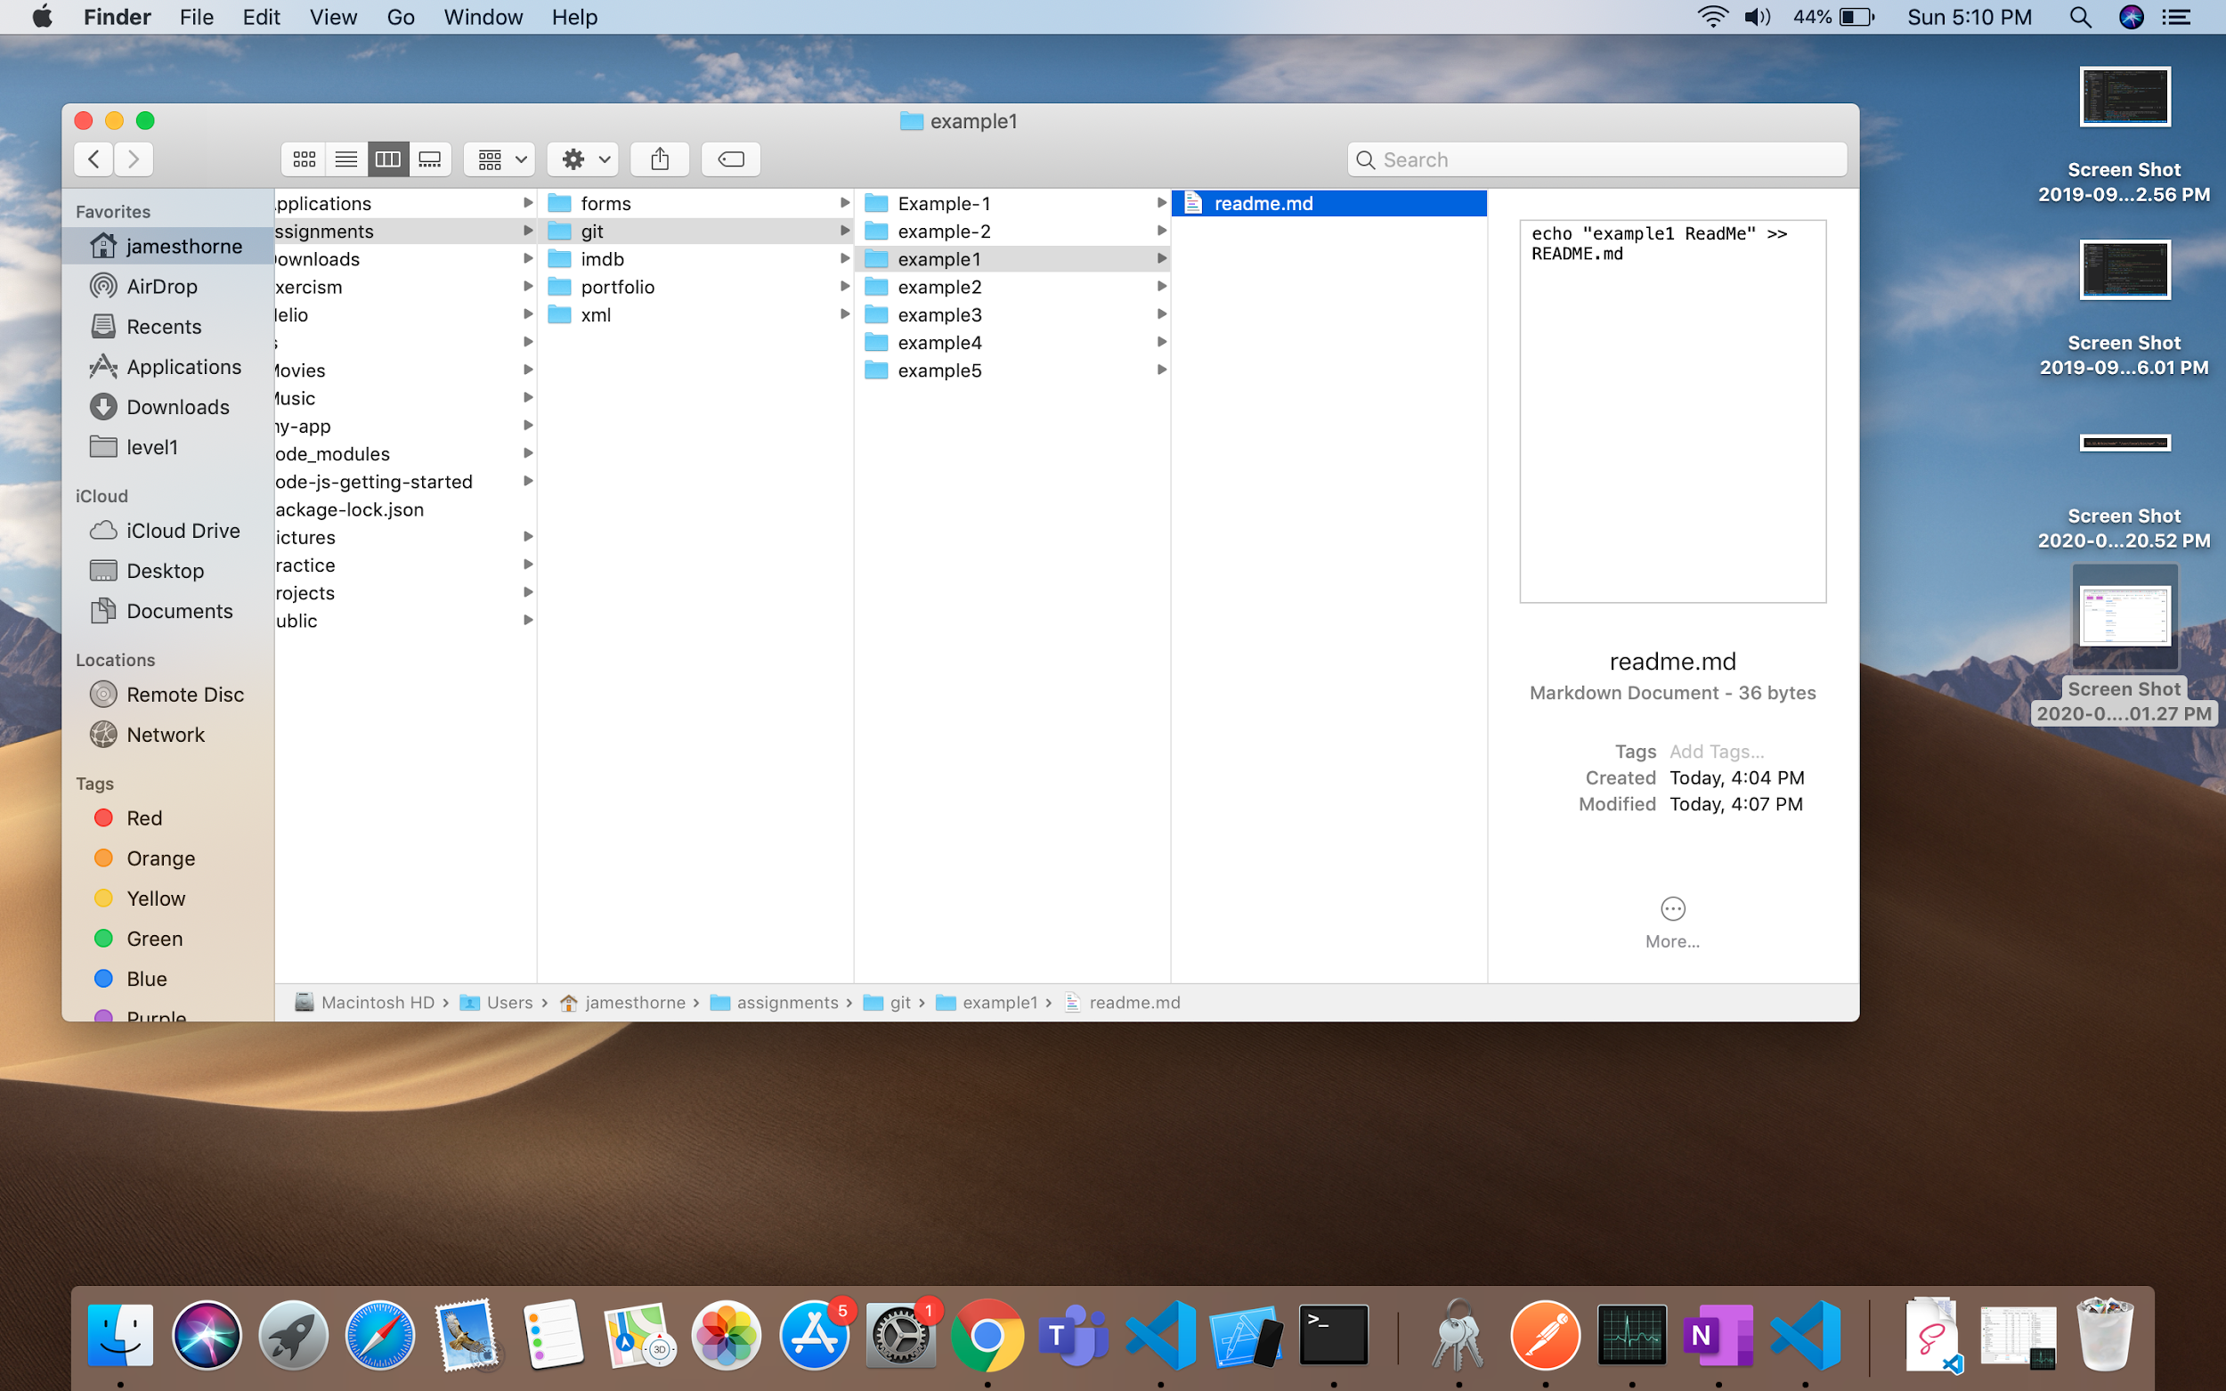

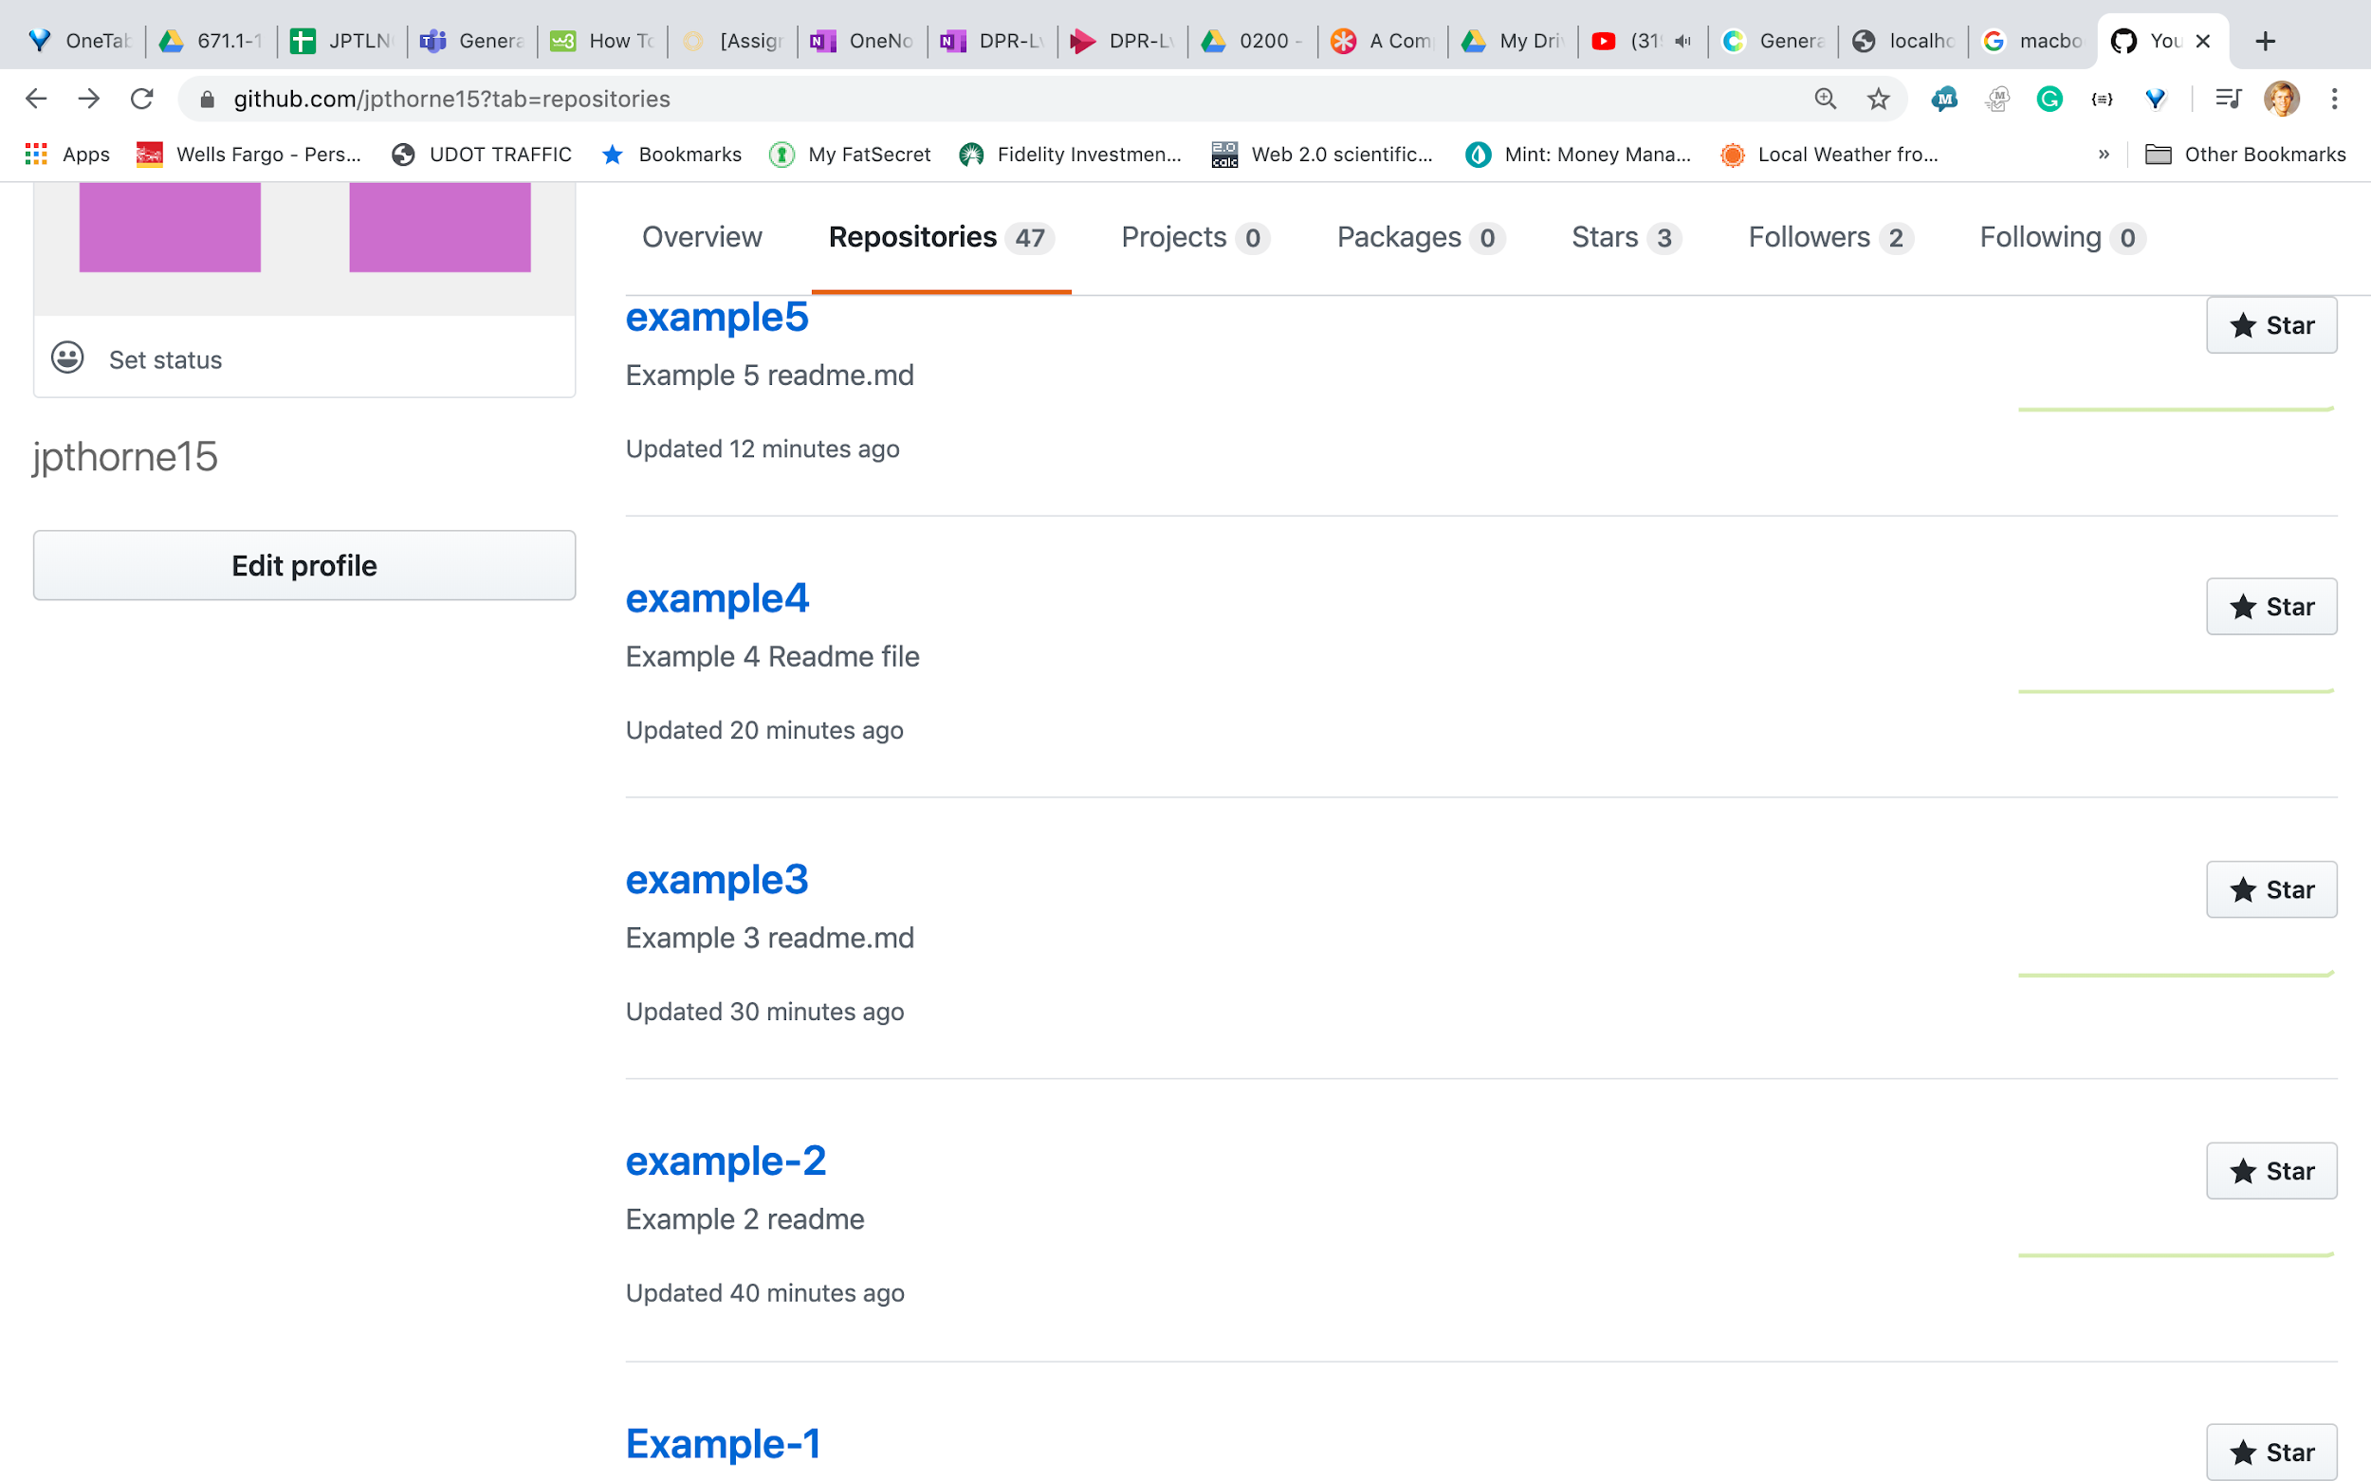

* What is GIT?
  + Free and open-source version control system designed to handle very small and large coding projects.
* Why do we have you learn GIT?
  + This makes so your code is online and available to others (if desired). It also acts as a backup tool so that you do not lose your source code if your laptop computer is lost, stolen, or damaged.
* What are the benefits of GIT over other tools like it?
  + Distributed Model: Your work is your own. You only let others see what is necessary
  + Branching and merging are easy
  + Workflow is flexible compared to a centralized VCS
  + Data integrity is assured. Data corruption easily detected.